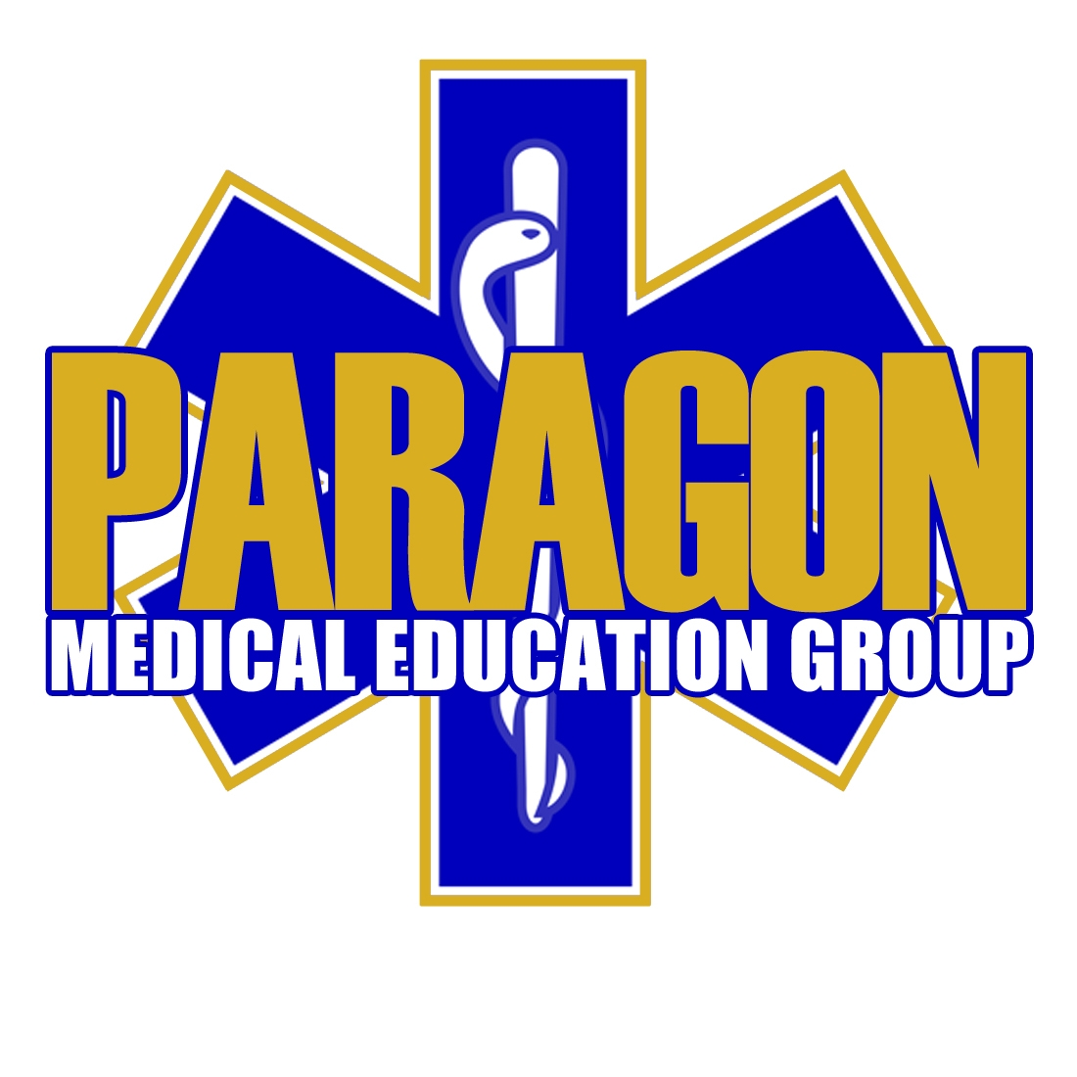
Consent for Photographing, Videotaping, and/or Audio Taping

I hereby grant permission to Paragon Medical Education Group, LLC,

To: [ ] photograph, [ ] videotape, and/or [ ] audio tape me

__________________________________________, for the purpose of, but not be limited to, the following forms of publication: website, photographs, videotapes, promotional items, news media, social networking (Twitter, Facebook, Blogs), and printed advertisements, with the following restrictions – (write NONE if no restrictions)___________________________
_____________________________________________________________________________

I hereby release Paragon Medical Education Group, LLC, and its affiliated corporations, officers, agents, employees, and medical staff from any and all claims and/or liability arising out of or in connection with such photographing, videotaping, and/or audio taping. The photograph taken by Paragon Medical Education Group, LLC involves no direct or indirect payment to or from the Student/Attendee, or from the party receiving the authorized photograph.

____________________________________________ ___________________________
Signature- Student/Attendee Date

____________________________________________ ___________________________
Witnessed By Date

