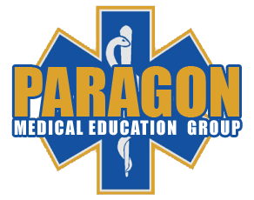

**Paragon Medical Education Group: *Active Shooter Medical Management Agenda***

8:00 Welcome and Introduction

8:15 Lecture with active participation

9:15 Break and report to activity sessions

9:30 Activity Sessions

Groups 1, 2, 3 Cadaver Labs (3 session rotation, 35 min/session)

· 1 - Hemorrhage Control

· 2 – Airway Management

· 3 – Ballistics & Anatomy

Groups 4, 5, 6 Exercise Prep Stations (3 session rotation, 35 min/session)

· 4 – Force Protection

· 5 – Sift & Sort

· 6 - Incident Command

11:15 Lunch

11:45 Activity Sessions

Groups 1, 2, 3 Exercise Prep Stations (3 session rotation, 35 min/session)

· 1 – Force Protection

· 2 – Sift & Sort

· 3 - Incident Command

Groups 4, 5, 6 Cadaver Labs (3 session rotation, 35 min/session)

· 4 - Hemorrhage Control

· 5 - Airway Management

· 6 – Ballistics & Anatomy

1:30 Break

1:45 Implementation Exercise, putting our skills to work

5:00 Debrief